- BISECTION METHOD
AIM: TO WRITE A PROGRAM IN PYTHON TO DEMONSTARTE BISECTION METHOD
PROGRAM:
import math

# Evaluate the user-defined function safely
def f(x, func_str):
try:
return eval(func_str, {"x": x, "math": math, "_builtins_": None})
except Exception as e:
print("Error evaluating function:", e)
return None

# Bisection Method
def bisection(func_str, a, b, tol):
if f(a, func_str) * f(b, func_str) >= 0:
print("Invalid interval. f(a) and f(b) must have opposite signs.")
return

print("Iter\t a\t b\t Xr\t f(Xr)")
iter = 1
while (b - a) / 2 > tol:
Xr = (a + b) / 2
fx = f(Xr, func_str)
print(f"{iter}\t{a:.3f}\t{b:.3f}\t{Xr:.3f}\t{fx:.3f}"
if abs(fx) < tol:
SIWS COLLEGE PRACTICAL NO 1

break
if f(a, func_str) * fx < 0:
b = Xr
else:
a = Xr

iter += 1

print(f"\nApproximate root = {Xr:.3f} (correct to 3 decimal places)")

# === Main Program ===
print("=== Bisection Method ===")
func_str = input("Enter the function f(x): ") # Example: x**3 - 4*x + 1
a = float(input("Enter the starting value a: ")) # Example: 0
b = float(input("Enter the ending value b: ")) # Example: 1
tol = 0.00003 # 3 decimal place accuracy

bisection(func_str, a, b, tol)

SIWS COLLEGE PRACTICAL NO 1

OUTPUT:

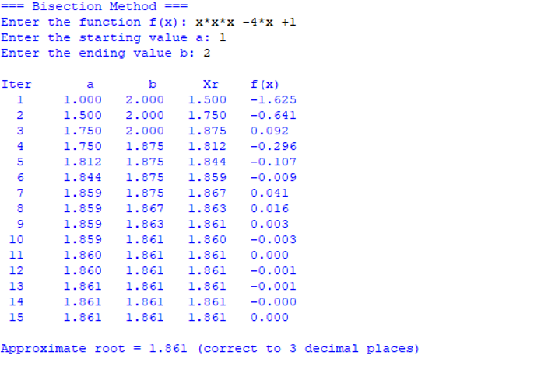
CONCLUSION: The above program has been executed successfully.

